Ta Quang Tung – 104222196

COS20019 – Cloud Computing Architecture - Wk9: ACA Module 13 Guided Lab - Implementing a Serverless Architecture with AWS Lambda

**Task 1 - Creating a Lambda function to load data**

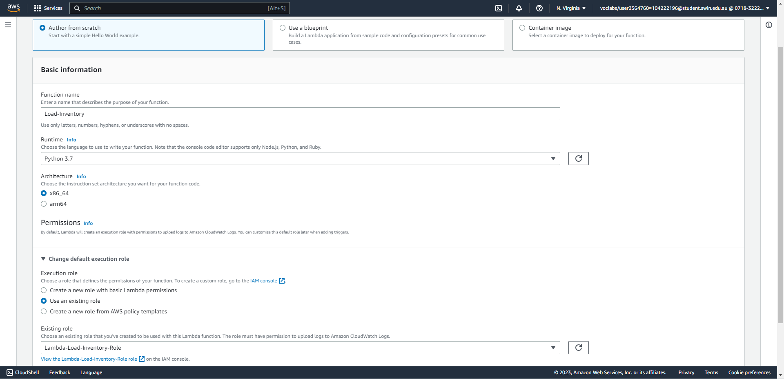



Create a new Lambda function to load an inventory file into the database, specifying its name, runtime, and IAM role.

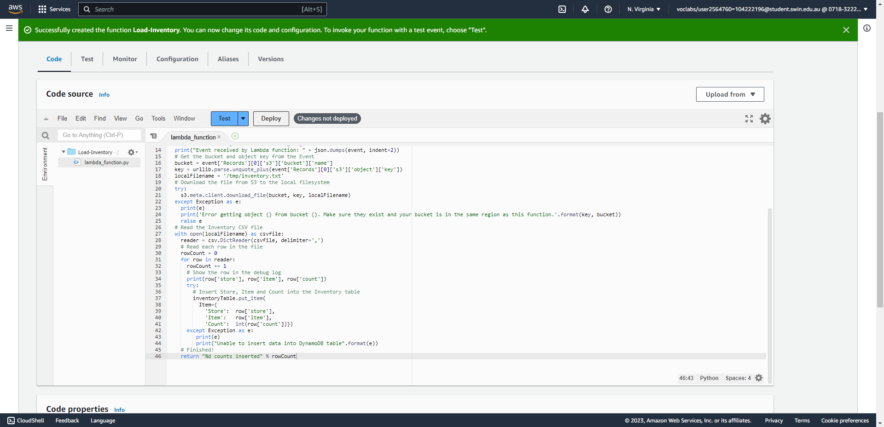



After the function is created, copy and paste the code into the function, then deploy.

**Task 2 - Configuring an Amazon S3 event**

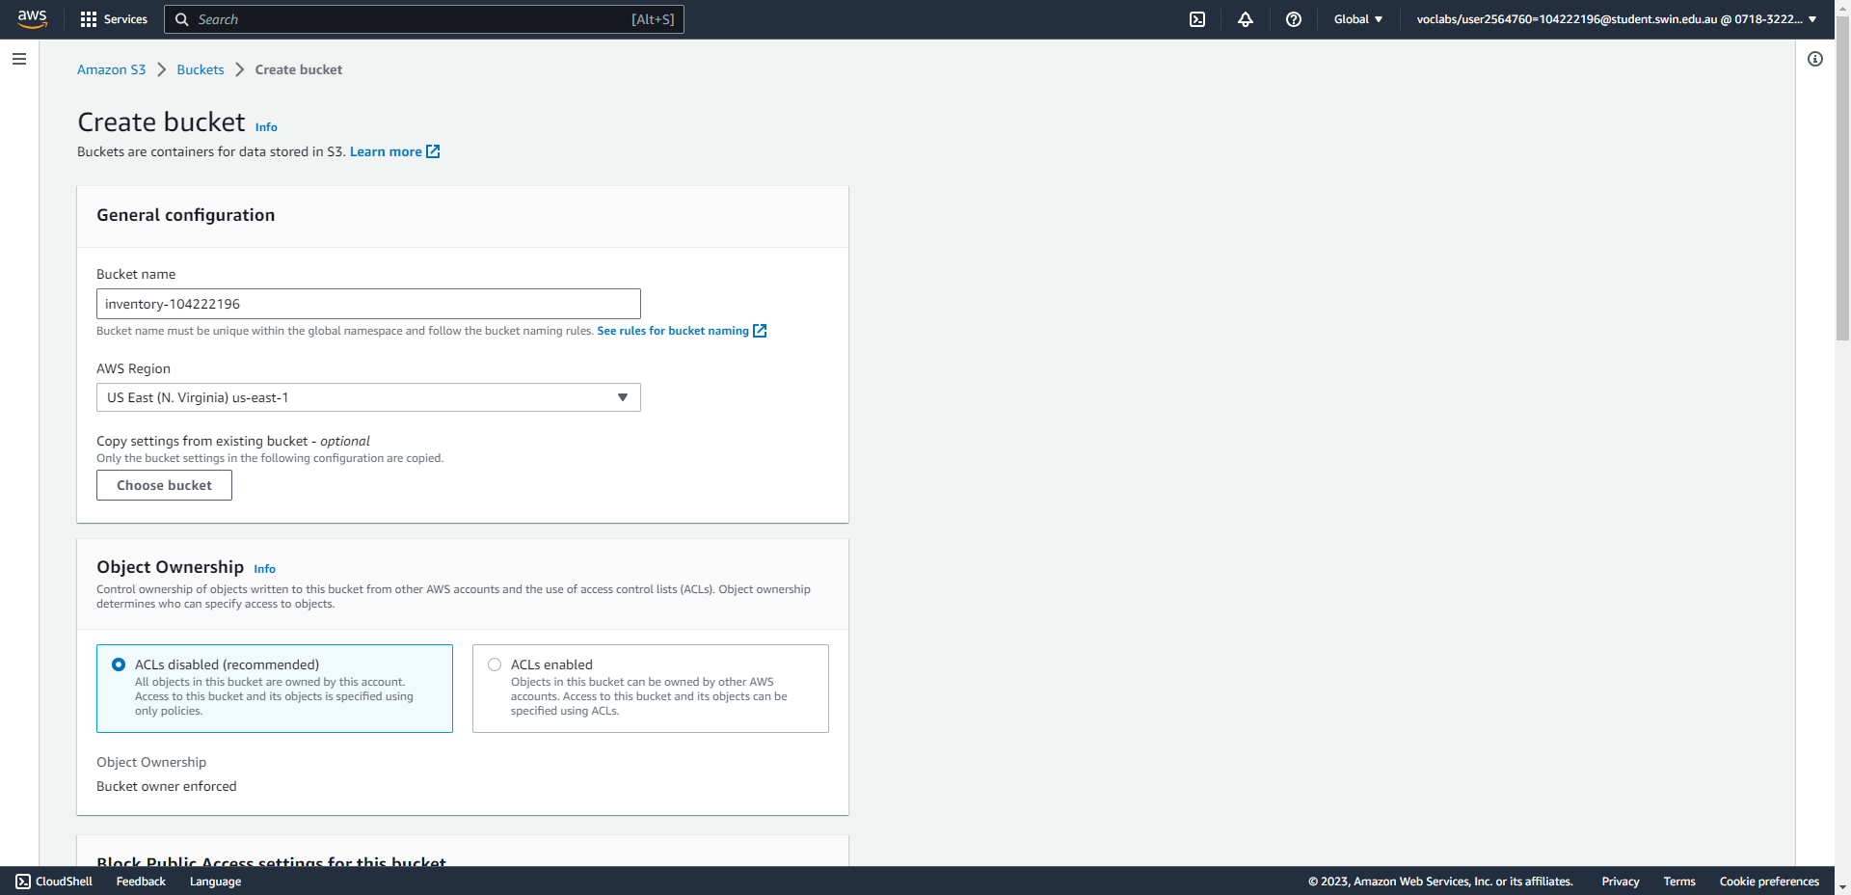



Create an S3 bucket with a unique name.

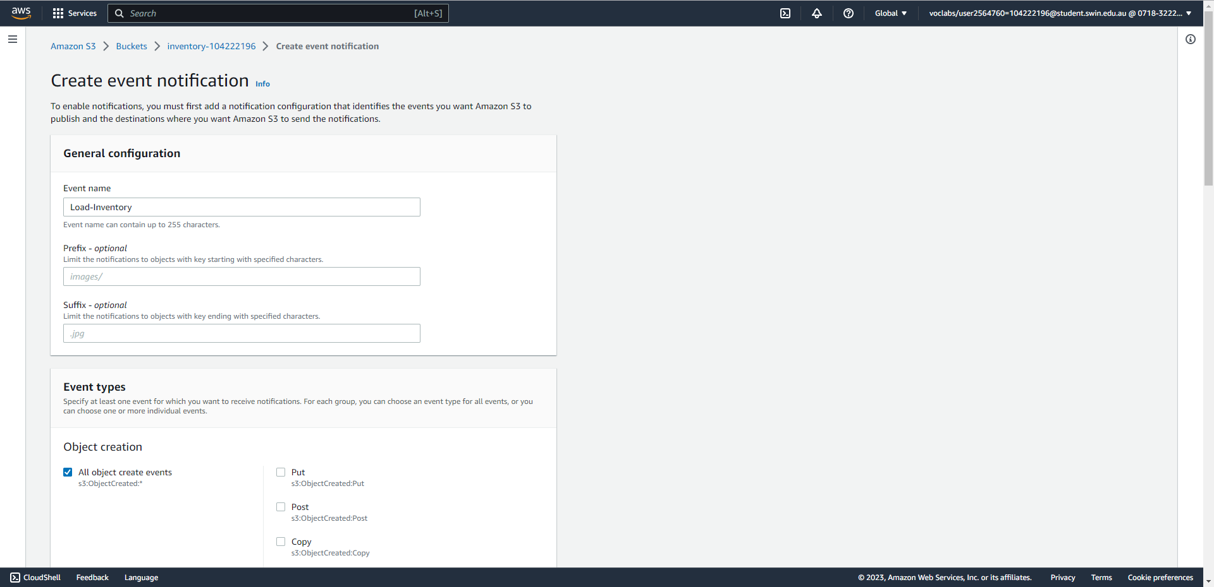



Create an event notification inside the S3 bucket (part 1/2), specifying its name and event type.

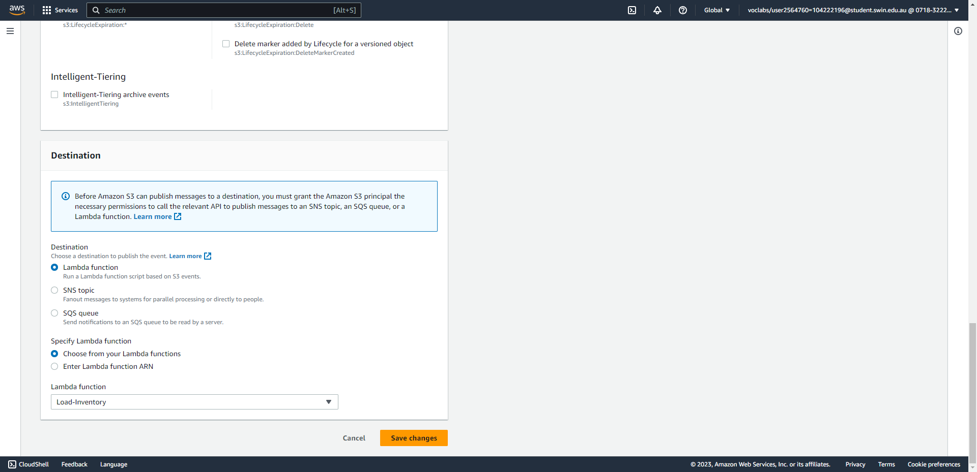



Create an event notification inside the S3 bucket (part 2/2), specifying its destination Lambda function.

**Task 3 - Testing the loading process**

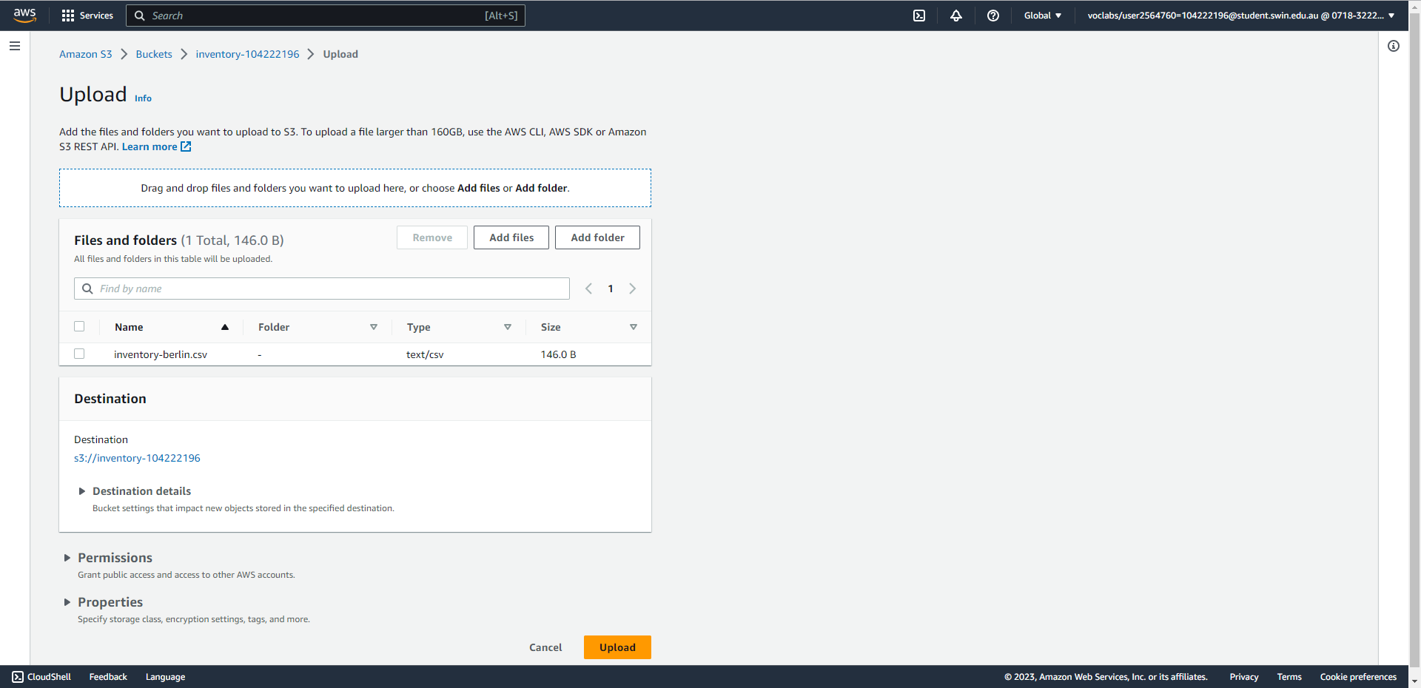



Upload an inventory csv file to S3.

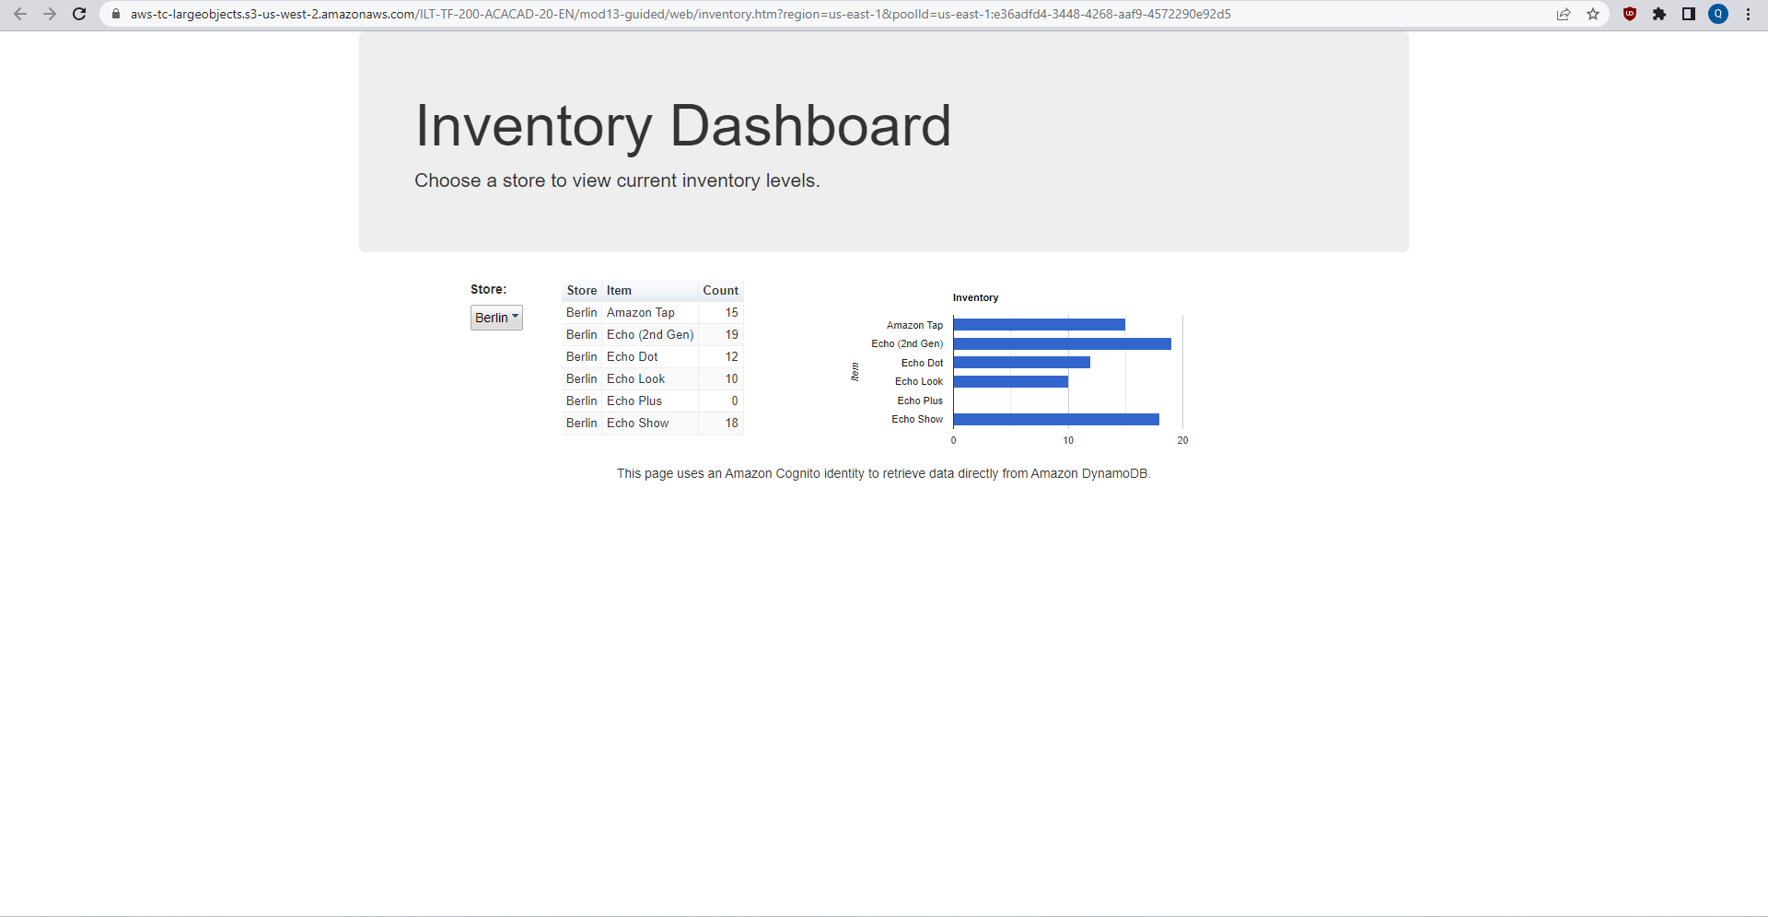



The dashboard page correctly shows the data loaded from the inventory file, meaning that the Lambda function has been correctly executed.

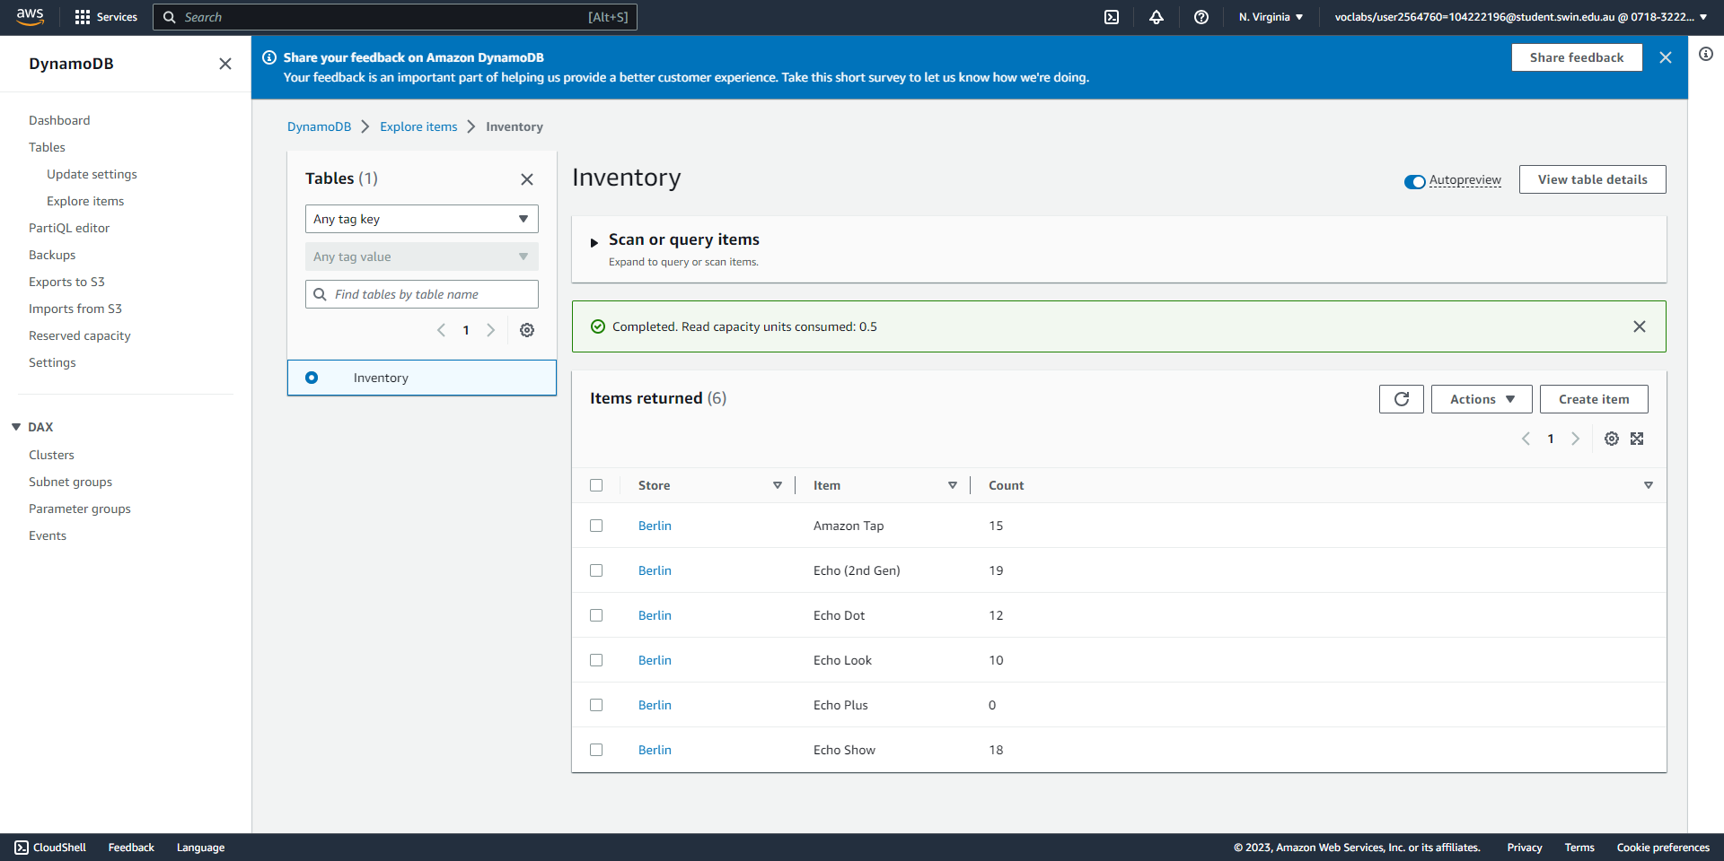

The data correctly appears in the DynamoDB database.

**Task 4 - Configuring notifications**

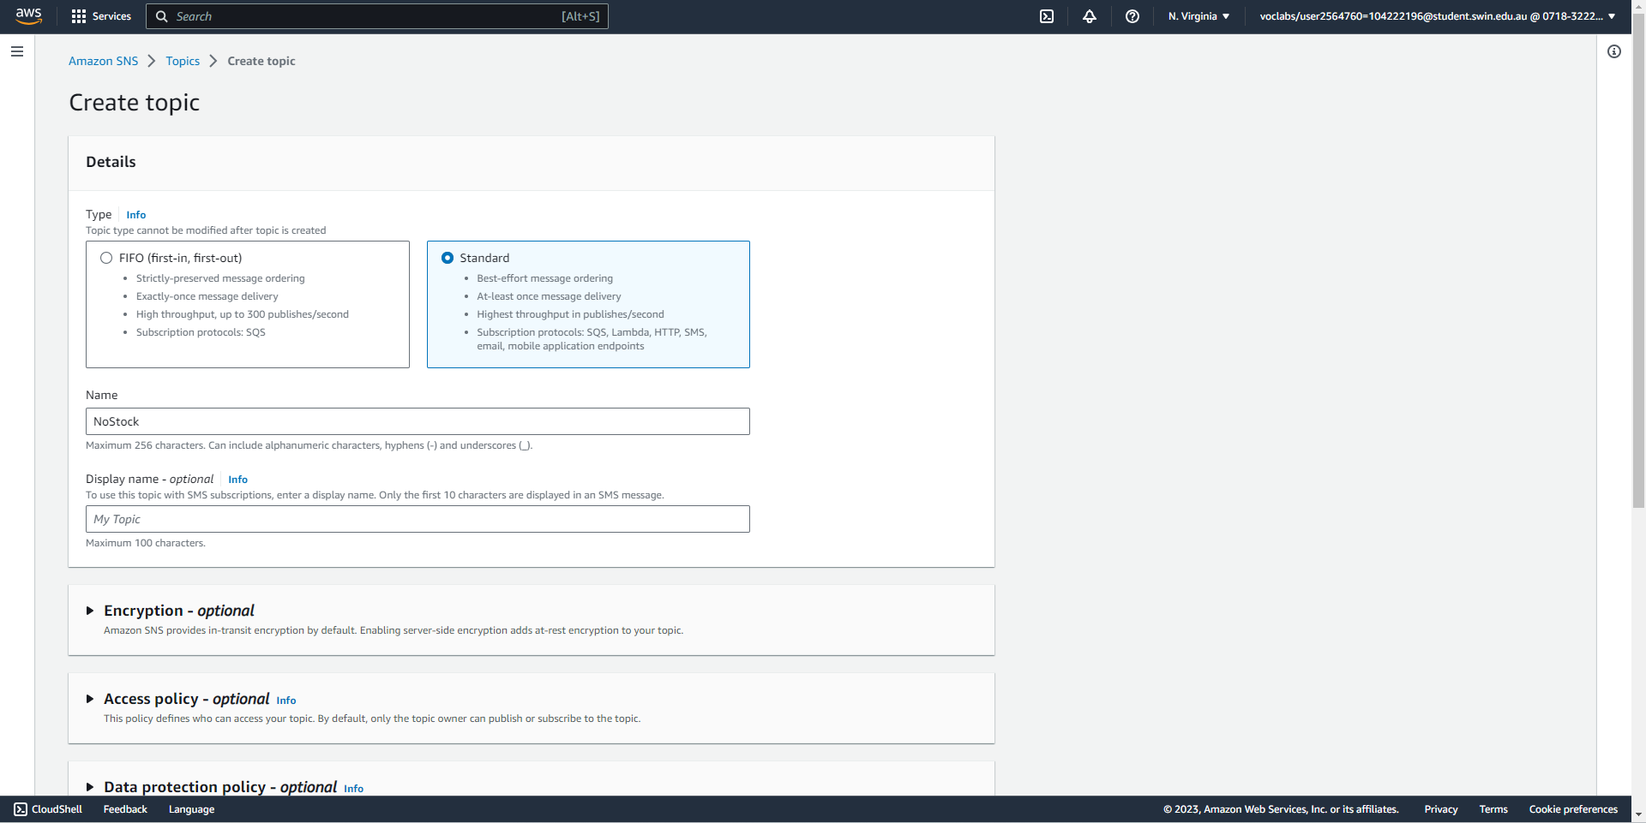



Create a standard SNS topic with the name of NoStock.

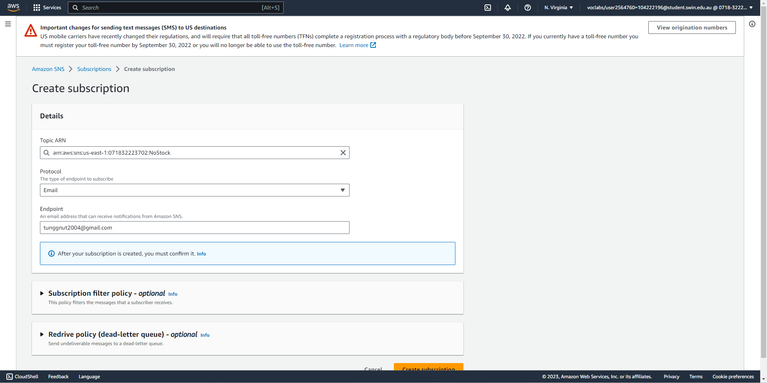



Create an email subscription to the SNS topic.

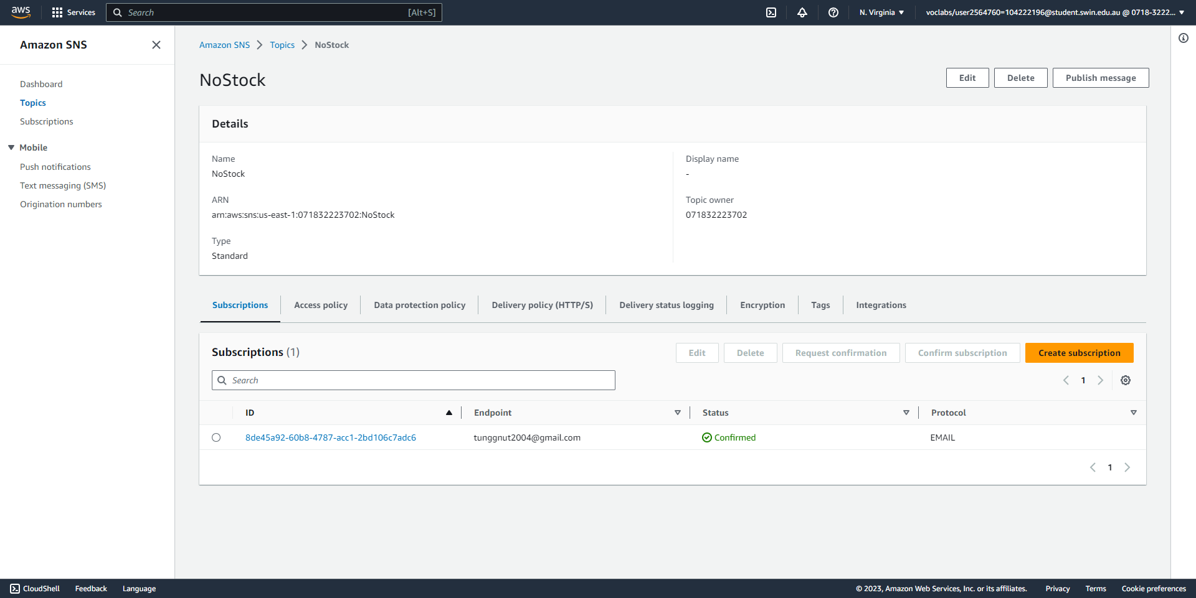



Confirm the email subscription to the SNS topic.

**Task 5 - Creating a Lambda function to send notifications**

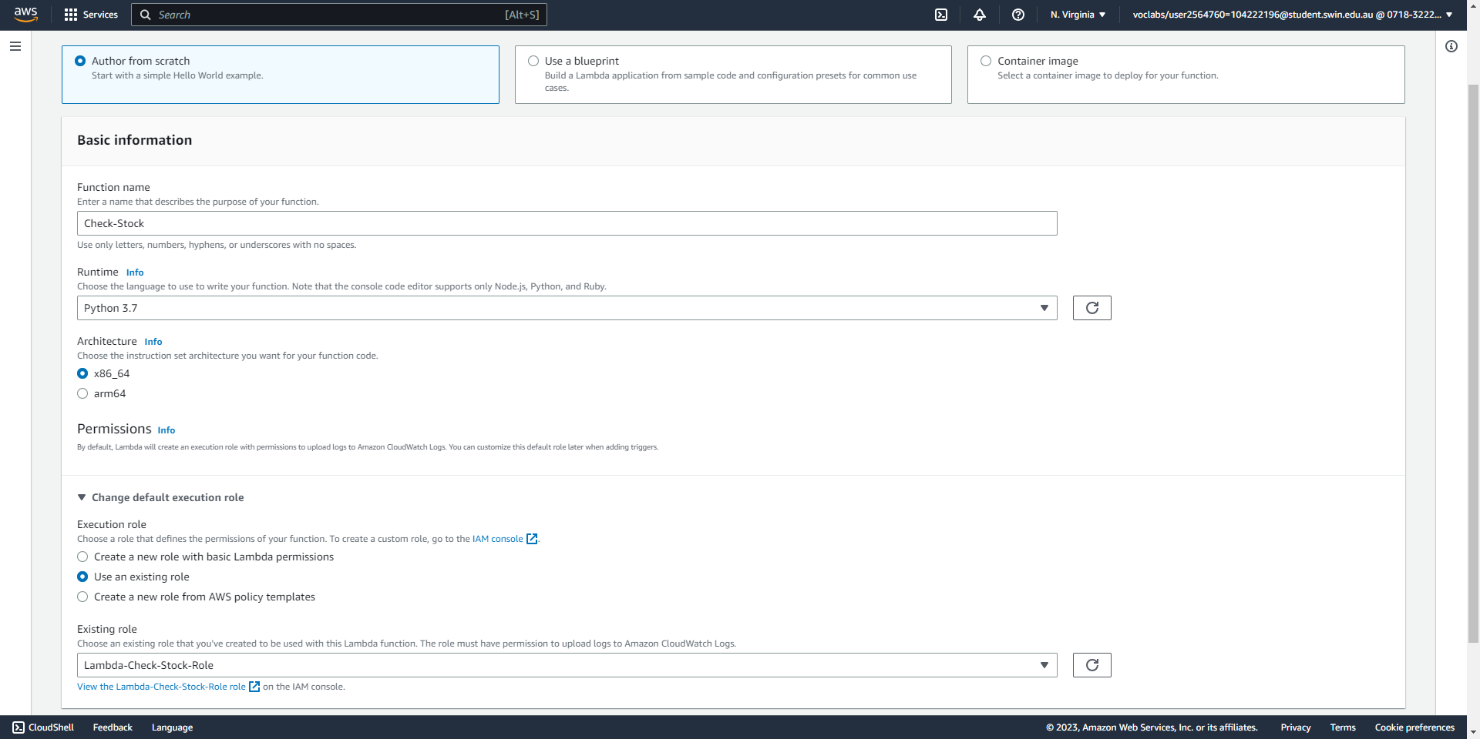



Create a new Lambda function to automatically sends email notifications, specifying its name, runtime, and IAM role.

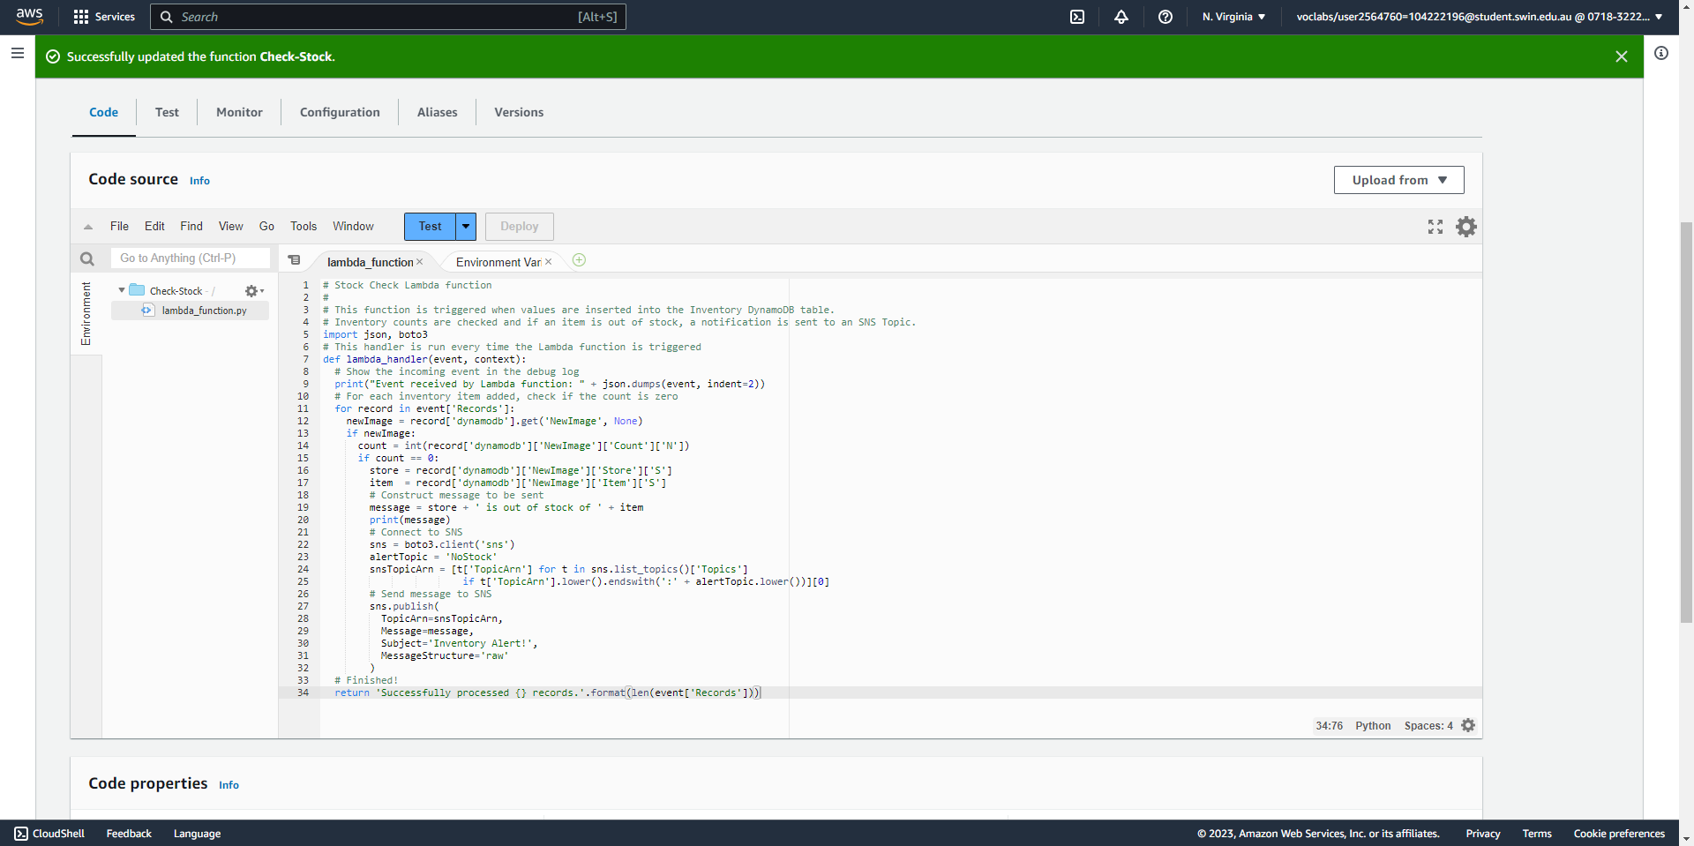



After the function has been created, copy and paste the code, then deploy.

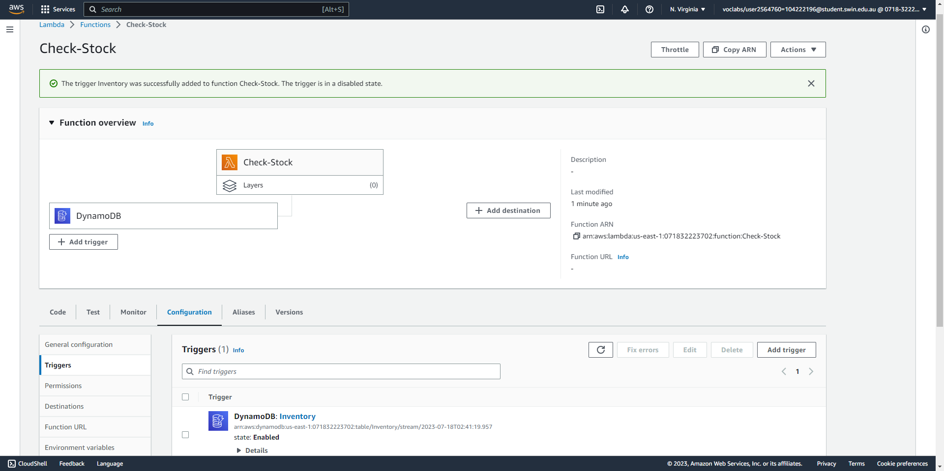



Add a trigger to the Lambda function, specifying the Inventory table in DynamoDB.

**Task 6 - Testing the System**

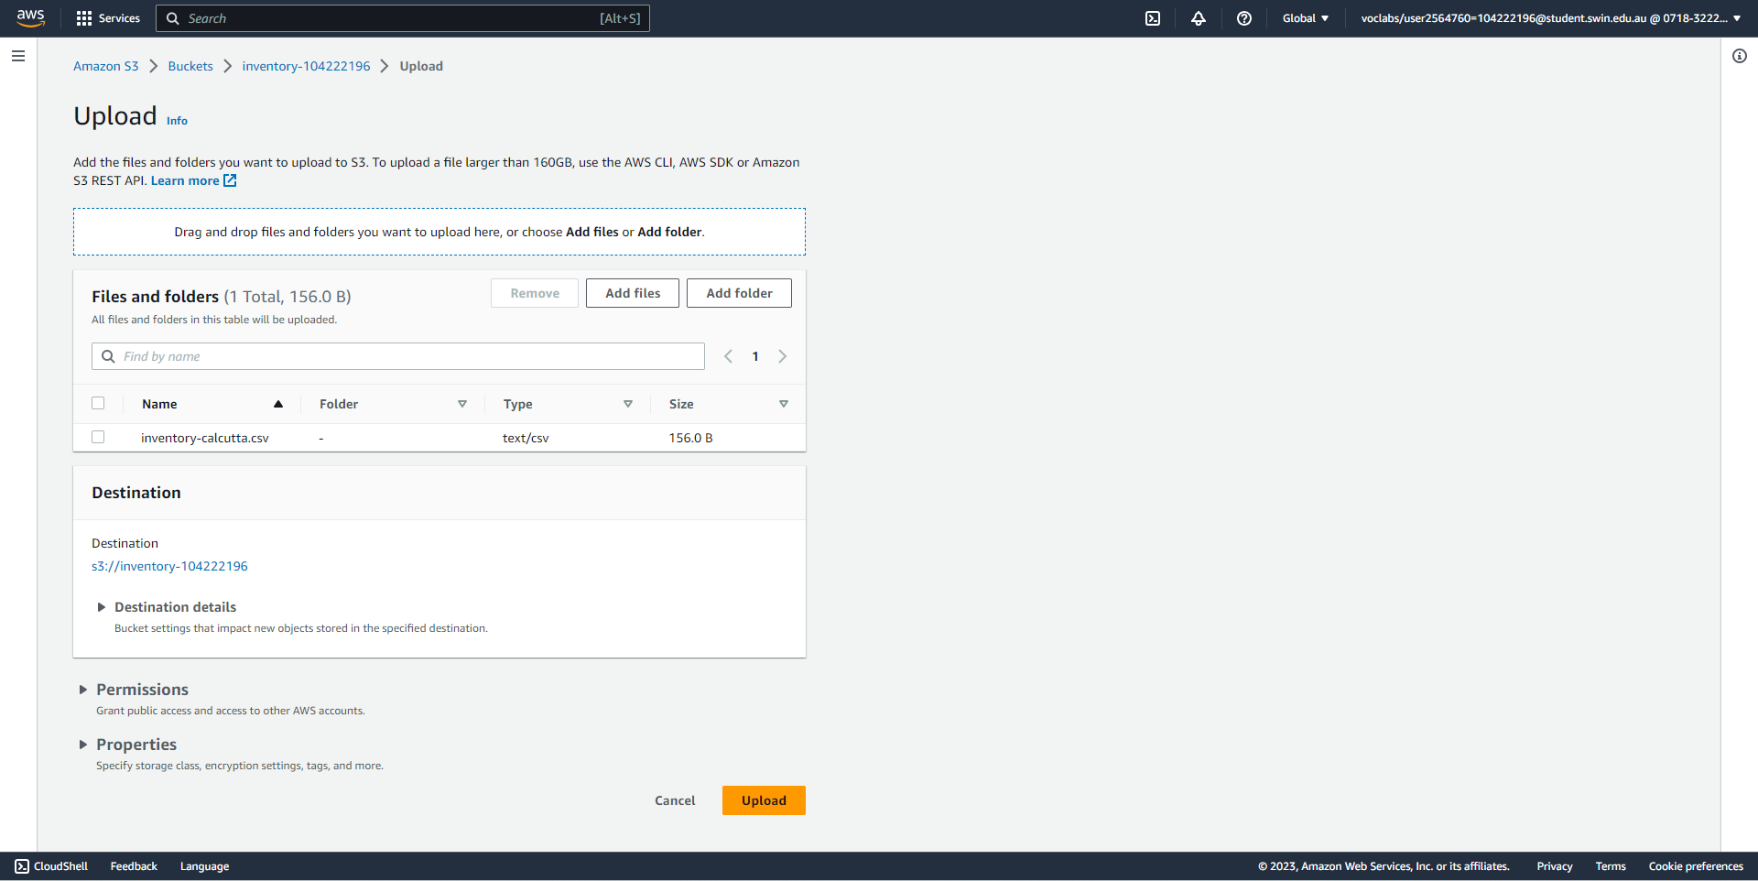



Upload another inventory file to S3.

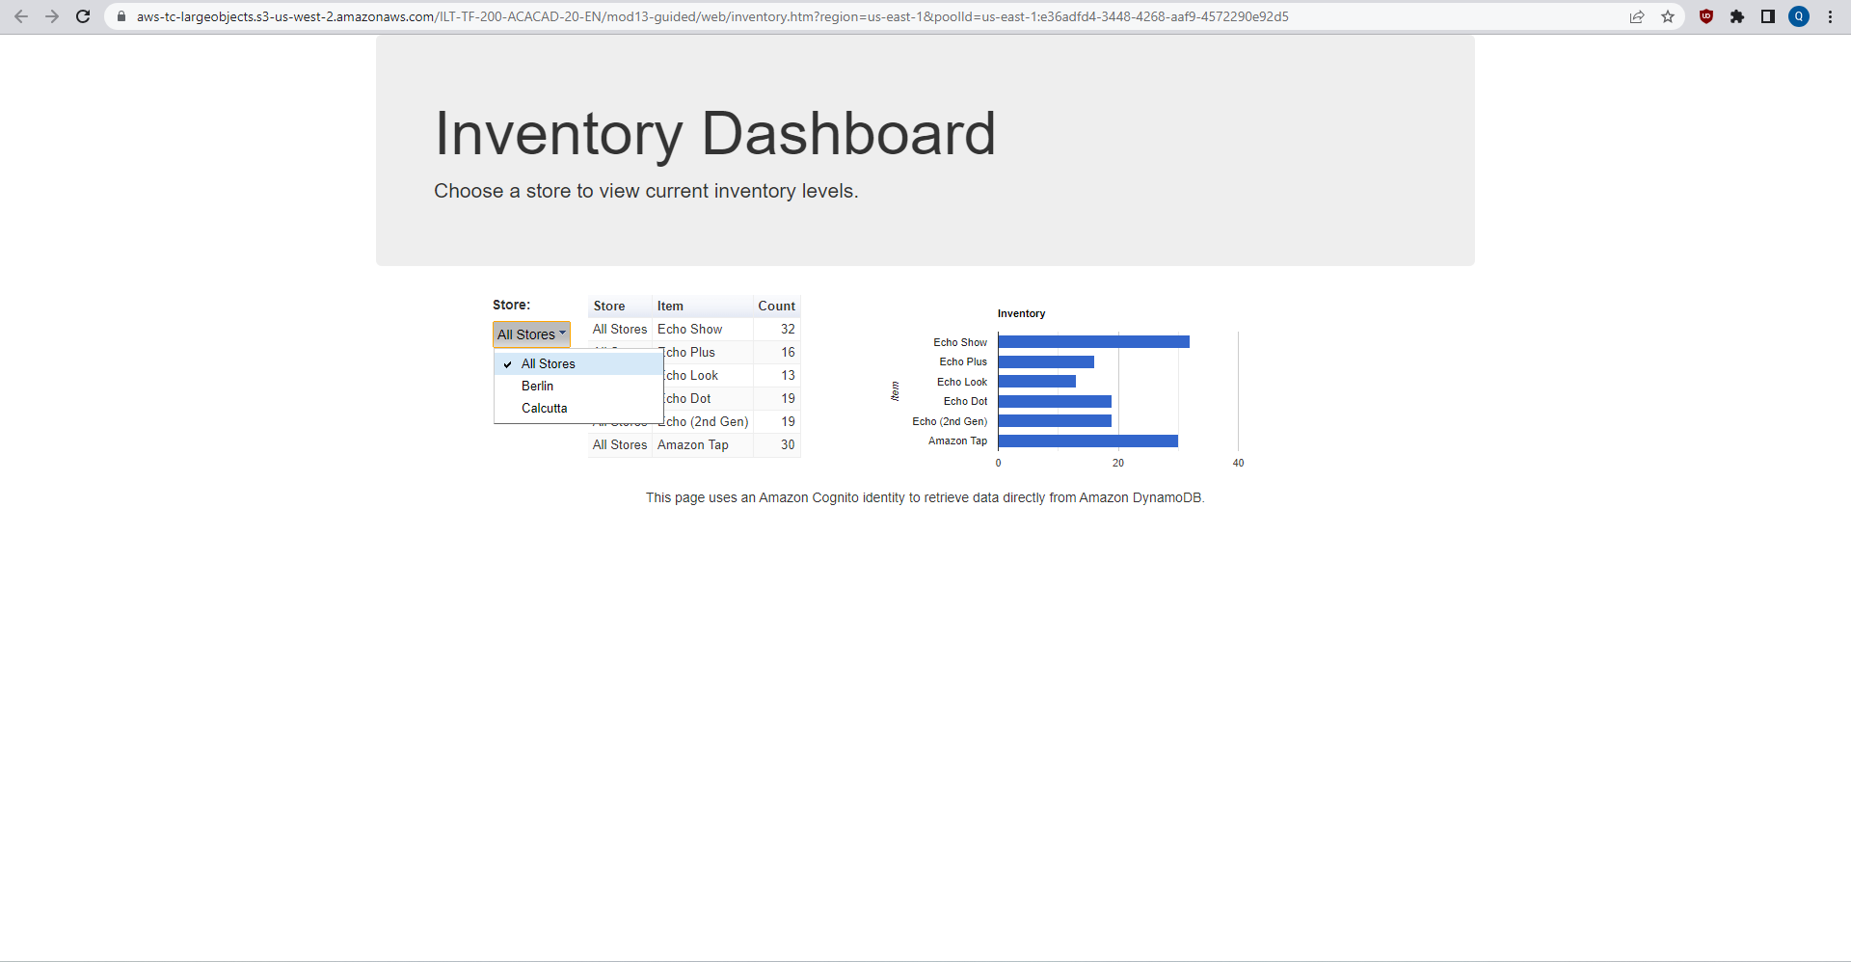



The new inventory file is correctly read and loaded into the database, as evidenced by the presence of a new store.

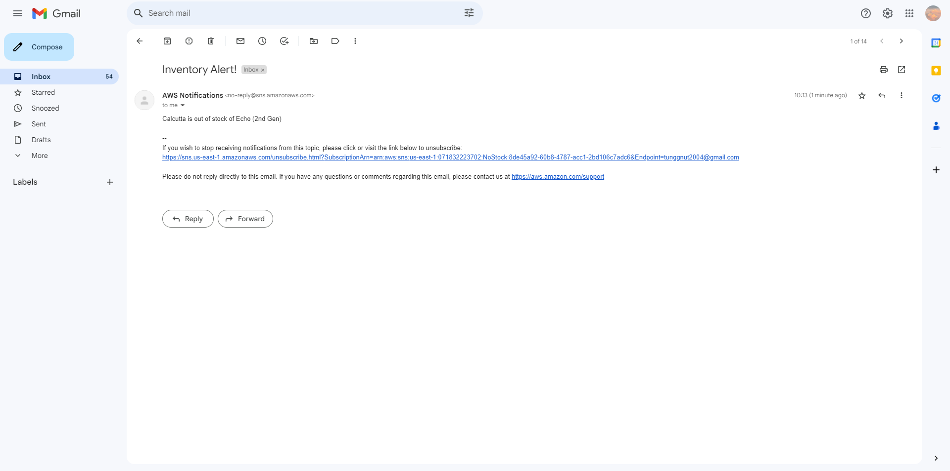

An email notification is sent to the subscribed email to inform that an item is out of stock.